CEBU INSTITUTE OF TECHNOLOGY
UNIVERSITY

COLLEGE OF COMPUTER STUDIES

Software Requirements Specifications
for
Adviser and Peer Evaluation System

PROPONENTS
Abdiano, Kent Dominic
Cortes, Ken Daniel
Ricablanca, Claudine Margaret
Pael, Neilross Ulysses
Rivera, Nico
Bajamunde, Louie V.
Magpatoc, Mark Andrew G.
Queddeng, James Adriane S.
Rigodon, Keith Yancy A.
Tabungar, Steven Jan M.

ADVISER
Cheryl B. Pantaleon

Change History

Table of Contents

Change History 2
Table of Contents 3
1. Introduction 4
1.1. Purpose 4
1.2. Scope 4
1.3. Definitions, Acronyms and Abbreviations 4
1.4. References 4
2. Overall Description 5
2.1. Product perspective 5
2.2. User characteristics 5
2.4. Constraints 5
2.5. Assumptions and dependencies 6
3. Specific Requirements 7
3.1. External interface requirements 7
3.1.1. Hardware interfaces 7
3.1.2. Software interfaces 7
3.1.3. Communications interfaces 7
3.2. Functional requirements 7
Module 1 7
Module 2 8
3.4 Non-functional requirements 8
Performance 8
Security 8
Reliability 8

Introduction

Purpose
The Adviser and Peer Evaluation System is a web-based platform designed to facilitate fair and efficient class evaluations. It enables students and advisers/teachers to submit, process, and analyze evaluation data while providing AI-generated summaries and insights. The system consolidates peer and adviser evaluation functionality, leveraging Google APIs for authentication and data integration. This SDD serves as a comprehensive reference for developers, testers, project managers, and stakeholders to ensure a shared understanding of the system’s design, components, and intended behavior.

Scope
The Adviser and Peer Evaluation System is a secure web application for academic institutions, combining peer and adviser evaluation functionality. It includes:
- User/Role Authentication via Google OAuth2
- Class and Team Management
- Student and Adviser Evaluation Modules
- Integration with Excel (.xlsx) and Google Forms for data input
- AI-Powered Summaries and Insights (BART/T5 or Google Gemini)
- Reporting and Exporting (PDF/CSV)
- Score Processing with adjusted averages
- Secure data handling and role-based access control
The system is intended for academic institutions conducting adviser and peer-to-peer evaluations across multiple classes and teams.

Definitions, Acronyms and Abbreviations
- AES – Adviser Evaluation System
- SRS – Software Requirements Specification
- SDD – Software Design Description
- API – Application Programming Interface
- AI – Artificial Intelligence
- NLP – Natural Language Processing
- Gemini – Google large language model used for summarization
- BART/T5 – Transformer models used for AI text summarization
- OAuth2 – Open Authorization 2.0
- RBAC – Role-Based Access Control
- JWT – JSON Web Token
- REST – Representational State Transfer
- DTO – Data Transfer Object
- ERD – Entity Relationship Diagram
- CRUD – Create, Read, Update, Delete operations
- HTTPS – Secure HyperText Transfer Protocol
- UAT – User Acceptance Testing
- CIT-U – Cebu Institute of Technology — University

References

- Kulkarni, C., et al. (2024). EvaluMate: Using AI to support students' feedback provision in peer assessment.
- Ma, Y., et al. (2022). PeerBERT: Automated characterization of peer review comments.
- Topping, K., et al. (2025). Enhancing peer assessment with artificial intelligence.
- Philippine Data Privacy Act of 2012 (RA 10173).
- APEER Software Requirements Specification (SRS), Version 3.0.
- Google Developers. (2025). Google Forms API. Retrieved from https://developers.google.com/forms/api
- Google Developers. (2025). Google Sheets API. Retrieved from https://developers.google.com/sheets/api
- Google Developers. (2025). Using OAuth 2.0 for Web Server Applications. Retrieved from https://developers.google.com/identity/protocols/oauth2
- Google AI Studio. (2025). Gemini API Reference. Retrieved from https://ai.google.dev
- Spring. (2025). Spring Boot Reference Guide. Retrieved from https://docs.spring.io/spring-boot/docs/current/reference/htmlsingle/
- Oracle. (2025). MySQL 8.0 Reference Manual. Retrieved from https://dev.mysql.com/doc/
- Meta. (2024). React Documentation. Retrieved from https://react.dev
- National Privacy Commission. (2012). Data Privacy Act of 2012. Retrieved from https://privacy.gov.ph/data-privacy-act/
- JWT Working Group. (2015). JSON Web Token (JWT) RFC 7519. Internet Engineering Task Force. Retrieved from https://www.rfc-editor.org/rfc/rfc7519
- Mozilla Developer Network. (2025). HTTP Fundamentals. Retrieved from https://developer.mozilla.org/en-US/docs/Web/HTTP/Overview
- Rescorla, E. (2018). The Transport Layer Security (TLS) Protocol Version 1.3 (RFC 8446). IETF. Retrieved from https://www.rfc-editor.org/rfc/rfc8446
- Fielding, R. (2000). Architectural Styles and the Design of Network-based Software Architectures. University of California.
- OpenAI. (2025). OpenAI API Reference. Retrieved from https://platform.openai.com/docs
- Hugging Face Inc. (2025). Transformers Library Documentation. Retrieved from https://huggingface.co/docs/transformers

Overall Description

Product perspective
The system is a web-based, client–server application composed of the following components:
- Frontend: React.js
- Backend: Spring Boot (Java)
- Database: MySQL
- AI Integration: Gemini API for automated summarization
- External Integrations: Google Forms API and Google OAuth 2.0
The platform transitions the current manual, paper-based adviser evaluation process into a centralized digital workflow. Teachers configure classes and teams, advisers evaluate their assigned teams, AI generates summaries of evaluation results, and teachers can view consolidated reports within the system.

User characteristics

Teacher
- Creates classes
- Adds students/advisers via sheets
- Forms teams
- Assigns students
- Assigns advisers
- Assigns questionnaires
- Generates AI-powered summaries

Adviser
- Views assigned teams
- Evaluates teams using system-provided questionnaires

Student
- Must have a valid Gmail account registered by the teacher.
- Can log in using Google authentication.
- Can evaluate peers and themselves using the provided evaluation form.

2.4. Constraints
- Must comply with the Data Privacy Act of 2012 (Philippines)
- Requires stable internet connectivity for continuous API communication
- Dependent on Google API availability (Forms, OAuth)
- AI summarization feature limited to the English language
- Must enforce strict Role-Based Access Control (RBAC):
  - Teachers cannot view or edit adviser accounts
  - Advisers can evaluate only the teams assigned to them
- Subject to Google API quota limits, which may affect synchronization
- System must remain accessible and responsive during peak evaluation periods

2.5. Assumptions and dependencies
- Google APIs (Forms, OAuth) remain stable and available
- Gemini API continues to support text summarization services
- Users have reliable internet access during system use
- Institution supports or provides necessary Google Workspace integration
- Spring Boot, JWT authentication, and all third-party libraries remain supported and compatible
- Changes in Google’s API policies may require system adjustments or updates
- Teachers will upload a correct Excel file with valid student names and Gmail addresses
- Uploaded Excel file controls who can log in

Specific Requirements

External interface requirements

3.1.1. Hardware interfaces
The Adviser Evaluation System requires standard hardware components for both server-side operation and end-user access. On the server side, the system should run on a machine—either cloud-hosted or on-premise—with at least a quad-core CPU, 8 GB of RAM, and SSD storage of at least 50 GB to ensure smooth processing and data handling. A stable internet connection is essential for continuous API communication with Google Forms, Google OAuth, and AI services. For users such as teachers and advisers, the system can be accessed through desktop or laptop devices capable of running modern web browsers, ideally with a screen resolution of 1366×768 or higher to ensure proper UI display. Mobile or tablet access may also be supported for advisers who need quick access to evaluations, although desktop use remains the primary mode of interaction.

3.1.2. Software interfaces
The system interacts with the following software components and platforms:
- Web Browsers (Frontend Access)
  - Google Chrome (latest version)
  - Microsoft Edge
  - Mozilla Firefox (optional support)
- Backend & Frameworks
  - Spring Boot (Java, version 3 or higher)
  - React.js for frontend interface
  - MySQL database server (version 8+)
- External APIs
  - Google Forms API: Fetching questionnaires
  - Google OAuth 2.0: For user-authorized form creation
  - AI APIs: Google Gemini, OpenAI, or Hugging Face for summarization
- Hosting Environment
  - Google Cloud Platform / AWS / Azure
  - VM Instance or Cloud Run / EC2 container support

- Security Middleware
  - Spring Security for authentication & role-based access
  - SSL Certificates for HTTPS encryption

3.1.3. Communications interfaces
The Adviser Evaluation System relies on secure and stable communication channels to ensure proper data exchange between users, the backend server, and integrated external services. All interactions between the client interface and the backend are conducted through RESTful APIs using standard HTTP or HTTPS protocols, with HTTPS being mandatory for encrypted data transmission. The system also communicates with external services such as the Google Forms API and AI summarization APIs through secure HTTPS requests, authenticated using OAuth 2.0 and access tokens. Additionally, the backend communicates with the MySQL database via encrypted JDBC connections to maintain data integrity and security. While real-time notifications are not part of the initial release, the system architecture allows for future integration of WebSockets or cloud messaging services to support real-time updates.

Functional requirements

3.2.1 Performance Requirements
- The system must load major pages (dashboard, class list, evaluation view) within 5 seconds or less under normal network conditions.
- Database operations (saving scores, updating team data) must complete in 2 seconds or less.
- AI summary generation must complete within 10–15 seconds, depending on API response times.
- The platform must support at least:
  - 200 concurrent users for medium-sized schools
  - 99% uptime for reliable access
- The system should efficiently handle:
  - Up to 500 classes
  - Up to 5,000 students
  - Up to 10,000 evaluation entries

3.2.2 Security Requirements
- Role-Based Access Control (RBAC)
  - Teachers can manage classes, teams, and reports.
  - Advisers can only evaluate their assigned teams.
  - Unauthorized access to restricted pages must be blocked.
- Authentication & Data Protection
  - All users must log in via Google OAuth.
  - Only emails pre-registered in the system by the Teacher via Google Sheets are allowed to log in.
  - User sessions must be protected using secure tokens.
- API Security
  - Google Forms API communication must use OAuth 2.0.
  - AI APIs must use encrypted tokens (no hardcoding).
- Data Privacy Compliance
  - Must comply with the Data Privacy Act of 2012 (Philippines).
  - Sensitive data must be stored and transmitted with encryption (HTTPS + database encryption where applicable).
- Input Validation & Protection
  - Prevent SQL injection, XSS, CSRF, and malicious file uploads.
  - Validate all user-submitted data (names, scores, comments).
- Audit Logs
  - System logs user actions (score submission, edits, login attempts).
  - Logs stored securely for monitoring and dispute resolution.

3.2.3 Reliability Requirements
- System Availability
  - Must maintain 99% uptime, excluding maintenance.
- Data Integrity
  - Evaluation scores must be saved accurately and cannot be corrupted during processing.
  - Changes must maintain referential integrity (class → team → adviser → evaluation).
- Backup & Recovery
  - Daily automated database backups.
  - Ability to restore data in case of server failure.
- Error Handling
  - System must display user-friendly error messages.
  - Critical failures must be logged automatically for developer analysis.
- Redundancy (Optional for future scaling)
  - Cloud load balancing
  - Duplicate failover instance
- Fault Tolerance
  - System should continue operating even during partial failures (e.g., AI API downtime).
  - Evaluation features should remain functional even if reporting module experiences issues.

Module 1 - Class Creation

1.1 Transaction Name: Class Creation

Use Case Description

The Class Creation module allows authorized Teachers to create, manage, update, and delete academic classes within the Adviser and Peer Evaluation System.

Each class serves as a container for students, teams, and assigned questionnaires. Only authenticated users with the role TEACHER are permitted to create and manage classes

Actors: Teacher (Authenticated user with TEACHER role)

Precondition:

The Teacher must be successfully authenticated.

The Teacher must have a valid TEACHER role.

The system must be operational and connected to the database.

Main Flow:

Teacher selects the “Classes” module in the dashboard.

System displays a list of classes created by the logged-in Teacher, including:

Class Name

Section

School Year

Number of Students

Number of Teams

Number of Questionnaires

Status (Active/Inactive)

Available Actions (Manage, Delete)
- Teacher selects “+ Create New Class.”
- System displays the Create New Class form.
- Teacher enters the required information:
- Class Name
- School Year
(Optional fields: Section, Description)
- Teacher sets the class status (Active by default).
- Teacher submits the form.
- System performs validation:
- Required fields are not empty.
- User is authorized as TEACHER.
- Input data format is valid.
- System automatically associates the class with the authenticated Teacher.
- System stores the new class in the database.
- System displays a confirmation message.
- System refreshes the class list to include the newly created class.

Alternative Flow

If required fields are empty → System displays validation error and prevents submission.

If user is not authorized → Access denied.

If database error occurs → System displays failure message and does not create class.

If Teacher selects Cancel → Form closes and no data is saved.

Postcondition:

The class is stored in the database.

The class is linked to the authenticated Teacher.

The class becomes available for:

Student Management

Team Formation

Questionnaire Assignment

1.2 Transaction Name: Student Management (Add / Edit / Remove)

Use Case Description

The system allows authorized Teachers to manage student records within their classes. Teachers can add new students, edit existing student information, assign students to classes, and remove students when necessary.

Actors: Teacher (Authenticated via Google OAuth)

Precondition:

Teacher is authenticated.

Teacher has TEACHER role.

At least one class exists in the system.

Main Flow:

Teacher selects the “Students” module in the dashboard.

System displays a list of students including:

Student ID

First Name

Last Name

Assigned Class(es)

Email

Phone Number

Available Actions (Edit, Delete)

Teacher selects “Add New Student.”

System displays the Add Student form.

Teacher enters required information:

Student ID

First Name

Last Name

Class Assignment(s)

Teacher optionally enters:

Email

Phone Number

Teacher submits the form.

System performs validation:

Required fields are not empty.

Student ID is unique.

Selected class(es) exist.

System stores the student record.

System confirms successful creation.

System refreshes the student list.

Teacher selects the “Students” module in the dashboard.

System displays a list of students including:

Student ID

First Name

Last Name

Assigned Class(es)

Email

Phone Number

Available Actions (Edit, Delete)

Teacher selects “Add New Student.”

System displays the Add Student form.

Teacher enters required information:

Student ID

First Name

Last Name

Class Assignment(s)

Teacher optionally enters:

Email

Phone Number

Teacher submits the form.

System performs validation:

Required fields are not empty.

Student ID is unique.

Selected class(es) exist.

System stores the student record.

System confirms successful creation.

System refreshes the student list.

1.3 Transaction Name: Mass Data Export

Use Case Description

The system allows teachers to export structured data for external record-keeping or institutional reporting.

Actors: Teacher

Precondition: Data must exist in the system.

Main Flow:

Teacher selects “Export Data.”

Teacher chooses data type:

Class Data

Team Assignments

Student Records

Evaluation Results

System generates structured Google Sheet or CSV file.

File is downloaded or saved to linked Google Drive storage.

Postcondition: Exported file is available for institutional use.

Module 2 - Adviser Evaluation Module

2.1 Transaction Name: Adviser Dashboard

Use Case Description

The system displays all classes and teams assigned to the authenticated adviser, allowing access to evaluation tasks.

Actors: Adviser

Precondition:

Adviser account exists in the system (created via data import).

Adviser is authenticated using system-issued credentials.

Adviser has been assigned to at least one team.

Adviser has been assigned to at least one team.

Main Flow:

Adviser logs in using system credentials.

System retrieves teams assigned to the adviser.

System displays:

Class Name

Team Name

Evaluation Status (Pending / Completed)

Adviser selects a team to evaluate.

Postcondition: Adviser gains access to the evaluation interface for the selected team.

2.2 Transaction Name: Evaluation & Scoring

Use Case Description
Allows advisers to evaluate assigned teams using internally created questionnaires with defined point values per question.

Actors: Adviser

Precondition:

Adviser has selected an assigned team.

Questionnaire exists and is linked to the team.

Questionnaire contains predefined questions with associated point values.

Main Flow:

System retrieves the assigned questionnaire from the internal database.

System displays:

Question text

Input field for score

Maximum point value per question

Adviser enters scores for each question.

System validates:

No required question is left unanswered

Entered score does not exceed maximum point value

Score is numeric and within allowed range

Adviser submits evaluation.

System stores evaluation data in the server database.

System synchronizes evaluation results to Google Sheets via API.

Postcondition:

Evaluation record is stored and marked as completed.

Data is available for reporting and AI summarization.

2.2 Transaction Name: Evaluation Tracking & Update

Use Case Description
Displays evaluation progress and allows advisers to review or modify submitted evaluations (if permitted).

Actors: Adviser

Precondition:

At least one team is assigned to the adviser.

System contains evaluation records for assigned teams.

Main Flow:

Adviser accesses assigned team list.

System retrieves evaluation status for each team.

System displays status indicators:

Completed

Pending

Adviser selects:

A Pending team → Opens evaluation form.

A Completed team → Views submitted scores.

If modification is allowed:

Adviser edits scores.

System re-validates updated entries.

System updates stored evaluation data.

System re-synchronizes changes to Google Sheets.

Postcondition:

Adviser can monitor evaluation progress.

Updated evaluations are reflected in storage and reports.

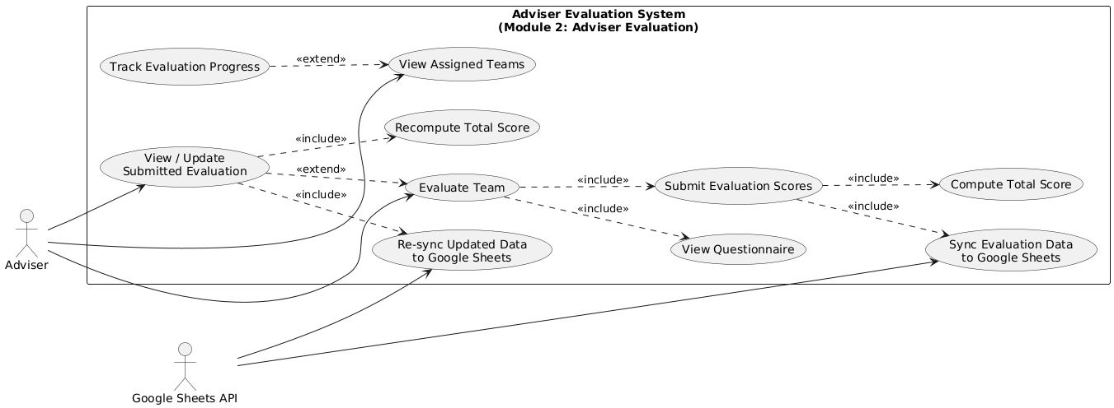

Module 3 - Reporting & AI Summarization Module

3.1 Transaction Name: Performance Ranking

Use Case Description
System calculates and displays team performance rankings based on adviser scores.

Actors: Teacher, System

Precondition: Adviser evaluations are completed.

Main Flow:

Teacher opens the reporting section.

System gathers all adviser scores.

System calculates averages and ranks teams.

System displays best-performing and lowest-performing teams.

Postcondition: Teacher sees updated team rankings.

3.2 Transaction Name:AI-Assisted Summary

Use Case Description
AI analyzes evaluation data to generate summaries, insights, and performance patterns.

Actors
- Teacher
- AI Service (Gemini / OpenAI)

Precondition
- Evaluation data must exist.

Main Flow
- Teacher clicks “Generate Summary.”
- System gathers evaluation scores and comments.
- System sends data to AI summarizer.
- AI returns:
  - Strengths
  - Weaknesses
  - Patterns
  - Team performance insights
- System displays the summary.

Postcondition
- AI-generated summary is shown on reporting page.

3.3 Transaction Name: Teacher Reporting Page

Use Case Description
Teacher exports summarized reports (PDF or CSV).

Actors
- Teacher

Precondition
- Reports and summaries must already be generated.

Main Flow
- Teacher clicks “Export.”
- System formats report (charts, rankings, summaries).
- System generates a PDF/CSV file.
- File is downloaded.

Postcondition
- Teacher now has a saved copy of the report.
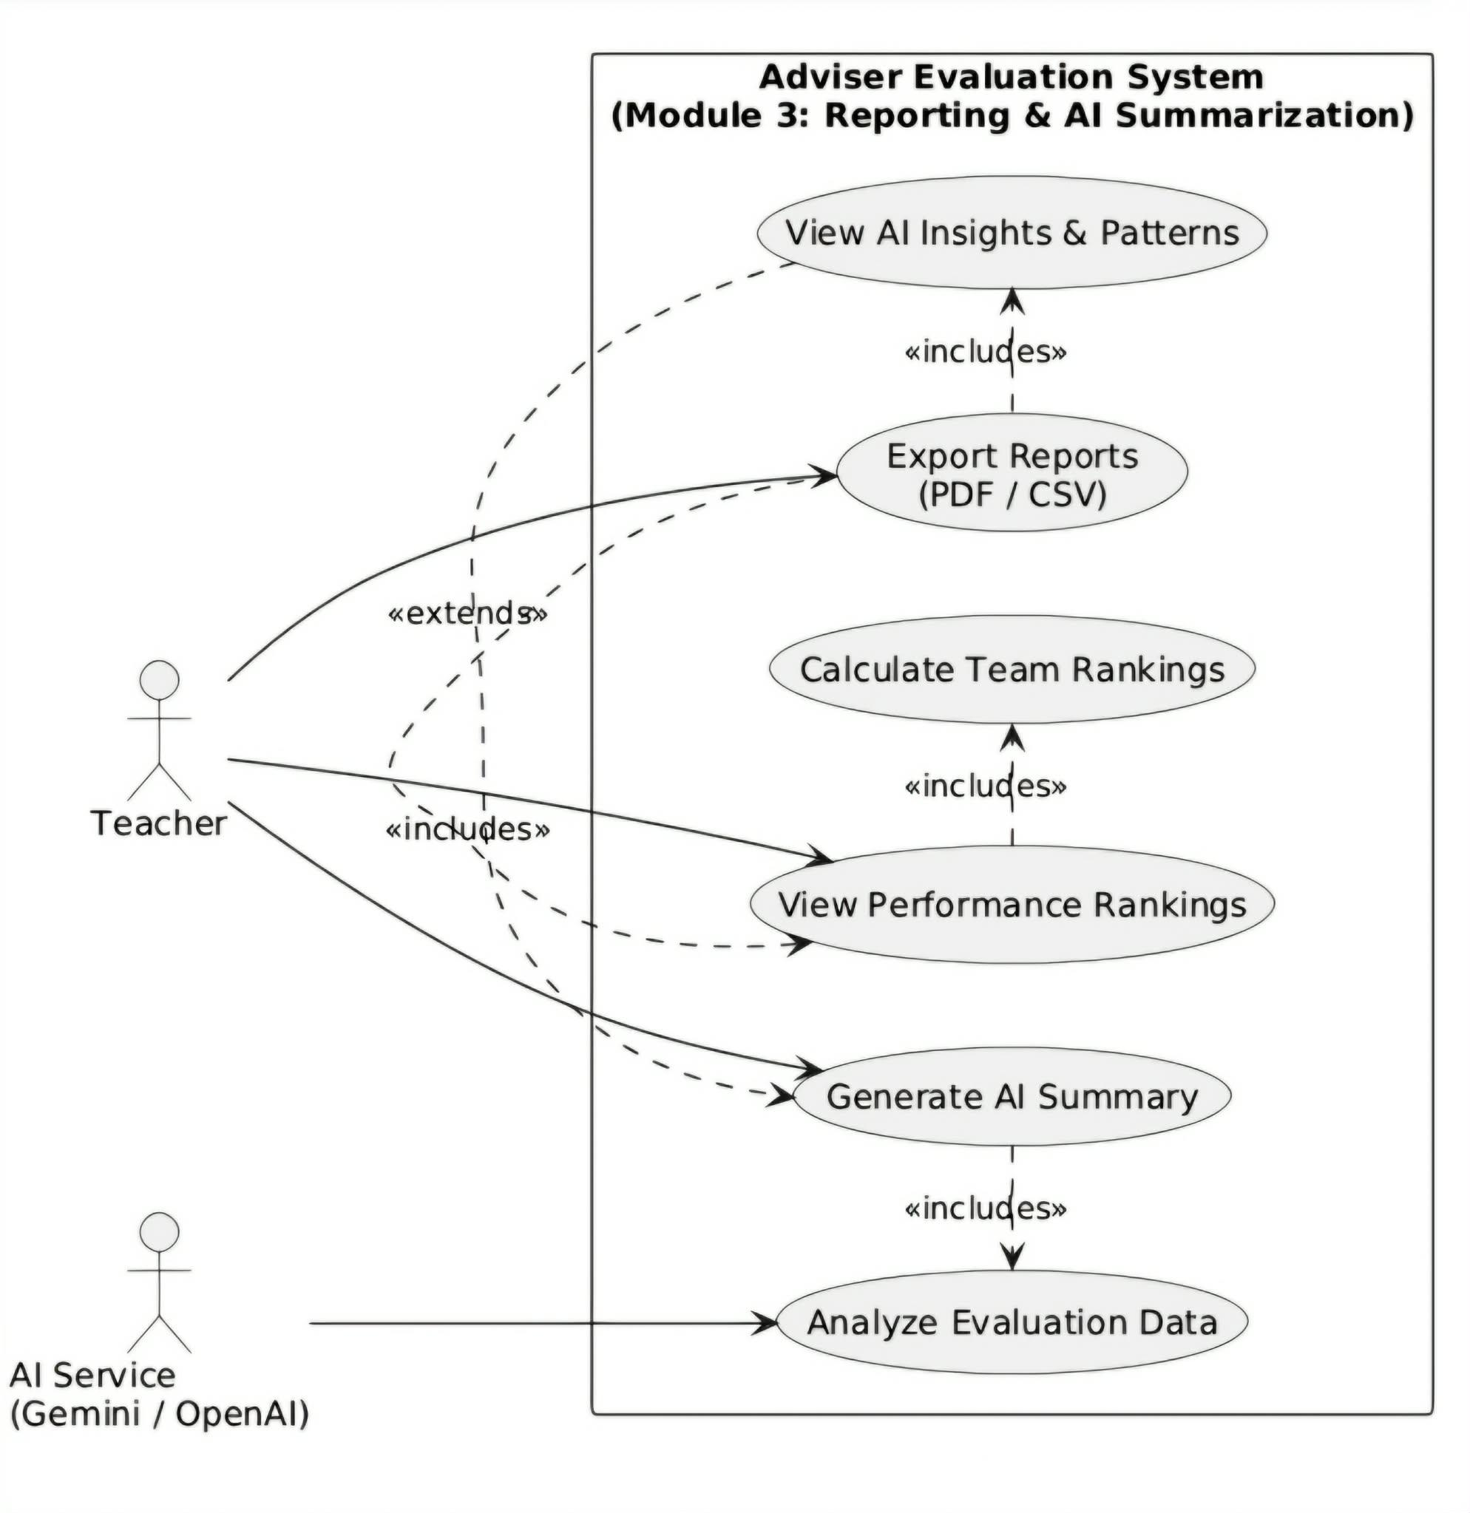

Module 4 - Student Management

4.1 Transaction Name: Student List (Teacher's Class Record)
Use Case Description
The teacher uploads an Excel (.xlsx) file to populate the class roster and authorize student access.
Actors
- Teacher
Precondition
- Teacher is logged in and has selected a specific class.
Main Flow:
- Teacher selects and uploads an Excel (.xlsx) file.
- System validates the file format.
- System extracts student names and Gmail addresses.
- System stores data in the student whitelist, replacing any existing list for that class.
Postcondition
- The authorized student list is updated and students can now log in or be selected for evaluation.

Module 5 - Self and Peer Evaluation

5.1 Transaction Name: Create Evaluation Session
Use Case Description
- The teacher defines the parameters, rubric criteria, and deadlines for a new peer evaluation activity.
Actors
- Teacher

Precondition
- A student whitelist (Module 4) must exist for the class.
Main Flow
  - Teacher enters evaluation session details: Title, Rubric Criteria (e.g., Participation, Cooperation), and Deadline.
  - Teacher submits the form.
  - System stores the activity details

Postcondition
- The activity is made accessible to all students in the class whitelist.

5.2 Transaction Name: Submit Peer Evaluation
Use Case Description
Students assign scores and provide qualitative feedback for their group members based on the defined rubric.
Actors:
- Student

Precondition
- Student is logged in and an active evaluation session exists for their class.

Main Flow:
  - Student views assigned group members (ordered by Excel upload).
  - Student assigns exactly one score (0-10) per member per criterion.
  - System validates that each member receives a unique score within the same criterion.
  - Student writes a mandatory comment.
  - Student submits the evaluation.
  - System triggers AI classification for the comment (Constructive, Vague, or Off-topic).

Postcondition
- Evaluation is recorded, scores are validated, and the comment is tagged for reporting.
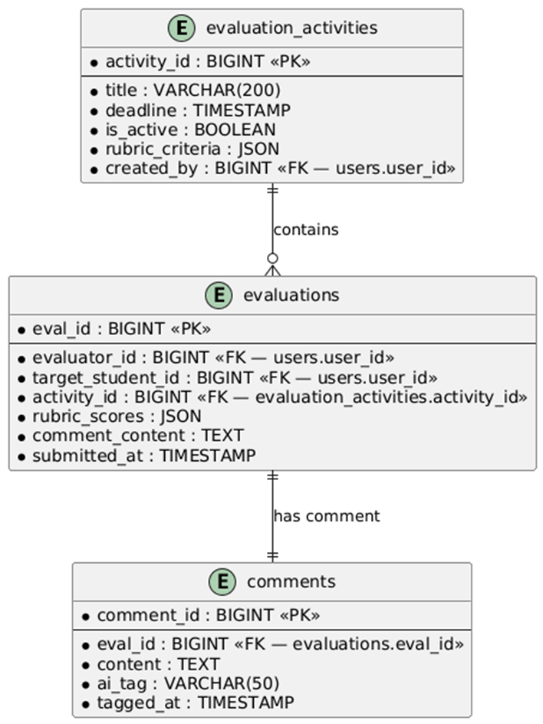

Module 6 - Authentication & Security Module

6.1 Transaction Name: User Authentication

Use Case Description
All system users must log in securely before accessing the system.

Actors
- Teacher
- Adviser
- Admin

Precondition
- User has an account.

Main Flow
- User enters their credentials.
- System verifies credentials.
- System grants access based on the user’s role.

Postcondition
- User accesses their appropriate dashboard.

6.2 Transaction Name: Role-Based Access

Use Case Description
The system restricts features based on user roles.

Actors
- System

Precondition
- User is authenticated.

Main Flow
- System identifies the user’s role (Teacher, Adviser, Admin).
- Teacher can create classes, teams, assign advisers, view reports.
- Adviser can only evaluate assigned teams.
- Admin can manage user accounts.
- Unauthorized actions are blocked.

Postcondition
- Users only access features allowed by their roles.

6.3 Transaction Name: Data Security

Use Case Description
The system ensures secure storage and transmission of evaluation data.

Actors
- System
- External APIs

Precondition
- System is connected to required services.

Main Flow
- System encrypts user credentials and evaluation data.
- All communication (Google API, AI API) uses secure channels.
- System validates all inputs to prevent attacks.
- System stores data securely and protects it from unauthorized access.

Postcondition: All sensitive data remains protected during storage and transmission.

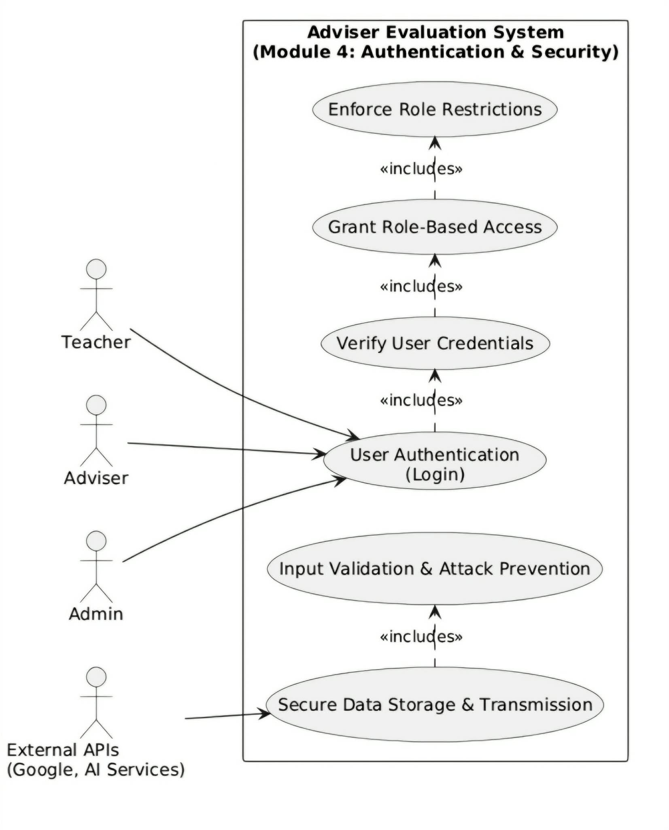

Module 7 - Data Import Module

1.1 Transaction Name: Class, Team, and Student Data Import

Use Case Description

The system allows authorized Teachers to import structured class, team, student, and adviser data using Google Sheets integration or CSV upload. The system validates, normalizes, and structures the imported data into relational database tables for evaluation and AI analytics processing.

Actors: (Authenticated via Google OAuth)

Precondition:

Teacher is authenticated using Google OAuth 2.0.

Teacher’s Gmail is pre-registered in the system.

Uploaded Google Sheets or CSV follows the predefined system template.

Required headers (Class, Team, Student Gmail, Role, Adviser Assignment) are present.

Main Flow:

Teacher selects the “Import Data” function in the dashboard.

Teacher either:

Uploads a CSV/.xlsx file
OR

Connects a Google Sheet via secure API integration.

System performs validation:

Required columns exist.

Gmail addresses follow valid format.

No duplicate student identifiers within the same class.

Roles are correctly defined (TEACHER / STUDENT / ADVISER).

Emails are authorized (whitelisted).

System processes and maps data relationally:

Students → Teams

Teams → Classes

Advisers → Assigned Teams

Roles → System access control

System normalizes imported data:

Removes redundant values

Standardizes naming conventions

Prepares dataset for evaluation processing and AI summarization

System stores validated and structured data in the backend database.

System generates an Import Summary Report containing:

Total records processed

Successful entries

Skipped rows

Validation errors

Alternative Flow

If file format is invalid → Upload rejected with error details.

If duplicate Gmail detected → Entry skipped and logged.

If role is undefined → Row rejected.

If email is not authorized → Access denied and entry skipped.

If Google API fails → System allows manual CSV upload fallback.

Postcondition:

Valid data is stored relationally in the database.

Users are authorized based on imported Gmail records.

System is ready for evaluation session creation and AI analytics processing.

1.2 Transaction Name: Data Update / Re-import

Use Case Description

The system allows Teachers to update existing class, team, student, and adviser data by re-importing an updated Google Sheet or CSV file. The system intelligently detects changes and synchronizes records.

Actors: Teacher (Authenticated via Google OAuth)

Precondition:

Initial dataset already exists.

Updated sheet follows the required format.

Teacher is authorized for the selected class.

Main Flow:

Teacher uploads updated sheet or reconnects Google Sheet.

System compares new dataset with existing database records.

System performs differential processing:

Creates new records for new entries.

Updates modified records.

Deactivates removed users (soft delete for audit purposes).

System maintains referential integrity:
Class → Team → Student → Adviser relationships remain valid.

System generates a Synchronization Report detailing:
      - New records added
      - Records updated
      - Records deactivated
      - Validation issues

Postcondition

System database reflects latest approved sheet data.

Gmail whitelist is updated automatically.

Role-based access remains enforced.

1.3 Transaction Name: Mass Data Export

Use Case Description

The system allows teachers to export structured data for external record-keeping or institutional reporting.

Actors: Teacher

Precondition: Data must exist in the system.

Main Flow:

Teacher selects “Export Data.”

Teacher chooses data type:

Class Data

Team Assignments

Student Records

Evaluation Results

System generates structured Google Sheet or CSV file.

File is downloaded or saved to linked Google Drive storage.

Postcondition: Exported file is available for institutional use.

Non-functional requirements

Performance

The system must support at least 200 concurrent student submissions without noticeable delays.

AI summarization should generate results within 5–10 seconds per evaluation batch.

Dashboard reports should load in under 3 seconds for up to 1,000 records.

API requests to Google Forms should be handled asynchronously to prevent blocking.

Security

All communication between client and server must use HTTPS with TLS 1.2 or higher.

User credentials must be stored securely using hashed and salted encryption (e.g., bcrypt or Firebase Auth).

Role-based access control will restrict students to evaluation submission and advisors/admins to data viewing.

The system must comply with the Philippine Data Privacy Act of 2012 and GDPR standards.

Sensitive data (evaluation responses, student identifiers) must be encrypted in transit and at rest.

Reliability

The system must have 99.5% uptime during evaluation periods (end of semester).

Automatic daily backups of evaluation data and summaries must be performed.

If API integration with Google services fails, the system should retry requests up to 3 times before flagging an error.

The system should gracefully handle unexpected failures, displaying error messages instead of crashing.

Module 7 - Data Import Module

7.1 Transaction Name: Class, Team, and Student Data Import

Use Case Description

The system allows authorized Teachers to import structured class, team, student, and adviser data using Google Sheets integration or CSV upload. The system validates, normalizes, and structures the imported data into relational database tables for evaluation and AI analytics processing.

Actors: (Authenticated via Google OAuth)

Precondition:

Teacher is authenticated using Google OAuth 2.0.

Teacher’s Gmail is pre-registered in the system.

Uploaded Google Sheets or CSV follows the predefined system template.

Required headers (Class, Team, Student Gmail, Role, Adviser Assignment) are present.

Main Flow:

Teacher selects the “Import Data” function in the dashboard.

Teacher either:

Uploads a CSV/.xlsx file
OR

Connects a Google Sheet via secure API integration.

System performs validation:

Required columns exist.

Gmail addresses follow valid format.

No duplicate student identifiers within the same class.

Roles are correctly defined (TEACHER / STUDENT / ADVISER).

Emails are authorized (whitelisted).

System processes and maps data relationally:

Students → Teams

Teams → Classes

Advisers → Assigned Teams

Roles → System access control

System normalizes imported data:

Removes redundant values

Standardizes naming conventions

Prepares dataset for evaluation processing and AI summarization

System stores validated and structured data in the backend database.

System generates an Import Summary Report containing:

Total records processed

Successful entries

Skipped rows

Validation errors

Alternative Flow

If file format is invalid → Upload rejected with error details.

If duplicate Gmail detected → Entry skipped and logged.

If role is undefined → Row rejected.

If email is not authorized → Access denied and entry skipped.

If Google API fails → System allows manual CSV upload fallback.

Postcondition:

Valid data is stored relationally in the database.

Users are authorized based on imported Gmail records.

System is ready for evaluation session creation and AI analytics processing.

7.2 Transaction Name: Data Update / Re-import

Use Case Description

The system allows Teachers to update existing class, team, student, and adviser data by re-importing an updated Google Sheet or CSV file. The system intelligently detects changes and synchronizes records.

Actors: Teacher (Authenticated via Google OAuth)

Precondition:

Initial dataset already exists.

Updated sheet follows the required format.

Teacher is authorized for the selected class.

Main Flow:

Teacher uploads updated sheet or reconnects Google Sheet.

System compares new dataset with existing database records.

System performs differential processing:

Creates new records for new entries.

Updates modified records.

Deactivates removed users (soft delete for audit purposes).

System maintains referential integrity:
Class → Team → Student → Adviser relationships remain valid.

System generates a Synchronization Report detailing:
      - New records added
      - Records updated
      - Records deactivated
      - Validation issues

Postcondition

System database reflects latest approved sheet data.

Gmail whitelist is updated automatically.

Role-based access remains enforced.

7.3 Transaction Name: Mass Data Export

Use Case Description

The system allows teachers to export structured data for external record-keeping or institutional reporting.

Actors: Teacher

Precondition: Data must exist in the system.

Main Flow:

Teacher selects “Export Data.”

Teacher chooses data type:

Class Data

Team Assignments

Student Records

Evaluation Results

System generates structured Google Sheet or CSV file.

File is downloaded or saved to linked Google Drive storage.

Postcondition: Exported file is available for institutional use.
